59 Bank Street, Level 1, Whangarei / P O Box 1223, Whangarei 0140  Meridian Building, Level 1, 93 Kerikeri Road, Kerikeri 0230  Phone: (09) 430 2090  Out of Area: 0800 832 383  Email: officewhg@homesupport.co.nz  Website: www.homesupport.co.nz | 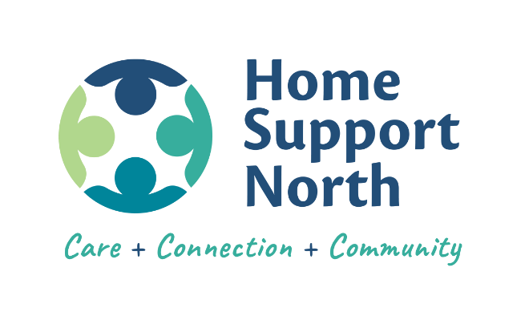

GP REFERRAL TO NASC REQUEST

Name of Person to be Assessed:
Phone: |  |  |  | Mobile:
Physical Address:
Postal Address:
NHI Number: |  | Email:
Reason for Referral:
Support Required: |  | ☐ Home Support ☐ Personal Care ☐ Has Community Services Card
Living Situation: |  | ☐ Lives Alone ☐ Lives with others ☐ Has had a fall
Further Info to Support assessment:
Person Requesting Referral: |  |  |  | Date:
Phone: |  |  |  | Mobile:

Please complete the details above and ask your GP to send to Northland DHB NASC:

NASC - Older Peoples
Northland District Health Board
Private Bag 9742 Whangarei
Phone: 09 430 4131
Fax: 09 430 4128
Email: nasc@northlanddhb.org.nz

